**SCHOOL OF ENGINEERING AND TECHNOLOGY**

**ASSIGNMENT / PROJECT SUBMISSION FORM**

**PROGRAMMES** **: Bachelor of Science (Honours) in Computer Science**  
  **Bachelor of Science (Honours) in Information Technology**

**SEMESTER** **: April 2024**

**SUBJECT** **: WEB1201 - Web Fundamentals**

**DEADLINE** **: 1 August 2024 23:59 MYT**

**INSTRUCTIONS TO CANDIDATES**

* This is a(n) ~~individual~~ / group project.

**IMPORTANT**

# The University requires students to adhere to submission deadlines for any form of assessment. Penalties are applied in relation to unauthorized late submission of work.

# Coursework submitted after the deadline but within 1 week will be accepted for a maximum mark of 40%.

# Work handed in following the extension of 1 week after the original deadline will be regarded as a non-submission and marked zero.

**Lecturer’s Remark** (Use additional sheet if required)

List down the name of the group members and the student IDs here.

I Lee Ming Hui Isaac (22057301), Yeap Chan Leong (22049837), Velan A/L Rajan (22058986), and Kim Hyunwoo (22021984) received the assignment and read the comments.

leeminghuiisaac, Chan Leong, Velan, 김현우 (1 August 2024) (Signature/Date)

**Academic Honesty Acknowledgement**

“I Lee Ming Hui Isaac (22057301), Yeap Chan Leong (22049837), Velan A/L Rajan (22058986), and Kim Hyunwoo (22021984) verify that this paper contains entirely my own work. I have not consulted with any outside person or materials other than what was specified (an interviewee, for example) in the assignment or the syllabus requirements. Further, I have not copied or inadvertently copied ideas, sentences, or paragraphs from another student. I realize the penalties *(refer to page 16, 5.5, Appendix 2, page 44 of the student handbook diploma and undergraduate programme)* for any kind of copying or collaboration on any assignment.”

leeminghuiisaac, Chan Leong, Velan, 김현우 (1 August 2024) (Student’s signature/Date)

**Data Protection**

The protection of personal data is an important concern to Sunway University and any personal data collected on this form will be treated in accordance with the Personal Data Protection Notice of the institution.

http://sunway.edu.my/pdpa/notice_english (English version), http://sunway.edu.my/pdpa/notice_bm (Malay version)

**1. Introduction**

Our website focuses on advocating for sustainability and assisting in achieving the United Nations' Sustainable Development Goals (SDGs). Our main goal is to increase knowledge and understanding about environmentally friendly products and encourage conscientious consumption. Our website covers the introduction, advantages, and purchasing options for our three main products: Bamboo straws, recycled bags, and solar lanterns.

The theme we have selected focuses on environmental awareness and the promotion of sustainable lifestyles. We stress the significance of minimizing plastic waste, promoting recycling, and harnessing renewable energy sources. Every one of our products adheres to these principles, providing practical and environmentally conscious alternatives to conventional items.

Providing a comprehensive explanation of the Account, Checkout, and Contact Us sections is imperative for utilizing our site and services, so we have made it a priority, since emphasizing sustainable living and environmental awareness is crucial to the message conveyed on our website. We have tailored each aspect of our website to prioritize both environmental sustainability and user convenience. Signing up and logging in are simple on the Account page, making the user experience smoother. The segments for Shipping Details, Payment Information, and Order Summary aid in structuring our checkout page, aimed at streamlining the buying process. This arrangement encourages mindful buying by highlighting the benefits each product has on the environment and enabling a simpler transaction process.

Our website serves as a central platform for sustainable products aimed at promoting environmental sustainability. Our objective is to facilitate the adoption of eco-friendly practices and promote a sustainable future by providing bamboo straws, recycled bags, and solar lanterns.

**2. Design Concept**

The design concept of our website emphasizes simplicity, minimalism, and accessibility, guaranteeing that it accommodates users of all age groups. By adopting a minimalist approach characterized by sleek lines, a restricted colour scheme, and generous use of space, we effectively minimize visual clutter and improve legibility, resulting in a user-friendly website. The design prominently showcases our three primary products, ensuring users can effortlessly locate and acquire knowledge about them. The website is designed to cater to a wide range of users by prioritizing user-friendly features such as larger fonts, intuitive navigation, and clear call-to-action buttons. Users with disabilities are supported by accessibility features such as alt text for images and navigation that is friendly for keyboard use. To prevent users from feeling overwhelmed, the design removes superfluous elements and prioritizes concise content, thereby enabling efficient information retrieval and ensuring a smooth browsing experience. The minimalist design is in line with our brand's contemporary and polished image, and it helps us achieve our business objectives by focusing attention on our main products. Our website's design concept combines simplicity and functionality to create an inclusive online environment that emphasizes our main products and offers an excellent user experience.

**3. Challenges and Solutions**

**HyperText Markup Language (HTML)**

The primary challenge faced during HTML implementations was understanding and using semantic HTML effectively. There were a lot of HTML attributes to choose from, leading to confusion about which attributes to use on sign-in, sign-out, and checkout pages. Using these elements incorrectly can result in poor accessibility and confusing code, making it difficult for other team members to understand the work. To address this, we learned the purpose of semantic elements using resources through W3Schools. This has helped us understand the correct usage of each attribute. Next, HTML elements were applied appropriately. For instance, to differentiate between the sign-in and sign-out sections, two <div> tags were used, successfully separating the content.

The second challenge was creating accessible forms. Accessibility issues arose when forms are not properly labelled, making navigation difficult for keyboard users and confusing for screen readers. To tackle this issue, research was conducted on how e-commerce websites implement form labels. We learned to properly associate <label> elements with their corresponding form controls, such as <input>, <textarea>, and <select>. This is done using the for attribute on the label and matching it with the id of the input element. This practice ensures that screen readers announce the label when users focus on the form control, improving accessibility.

The third challenge was handling multimedia content responsively. Ensuring that videos and images are responsive is crucial; otherwise, they can disrupt the webpage layout on different devices, leading to a poor user experience. To make images responsive, the srcset attribute was used with the <img> tag. This attribute allows different image resolutions to be served based on the device's screen size and resolution, optimizing loading times and ensuring that images look sharp on all devices. Additionally, <div> tags were used to separate content, making it easier to place images and videos independently and preventing them from stacking up on top of or below each other.

**Cascading Style Sheets (CSS)**

The major challenge faced during CSS implementations is maintaining a consistent design. As the project grew in the number of files, confusion arose from other group members trying to implement their functions to improve the website's visibility. Knowing that inconsistent styling may affect our group's performance and efficiency, a style guide was created for everyone to adhere to the standards and formats, making styles to be applied consistently, examples are colours, typography, spacing, and commonly used components. This allows web designers to make changes easily and without confusion, and potential customers to view and be interested in purchasing products.

The second challenge faced when implementing CSS in our files is performance optimization. As our group has a total of twelve code files to run smoothly, the loading time and responsiveness of the web pages were a concern as potential customers would not have the patience to wait. In response, unused styles were removed, and the usage of complex selectors was decreased significantly.

Consequently, customers' user experience can be significantly improved which will interest potential customers to buy more.

The third challenge in CSS implementation is handling layout. Although this challenge is minor, it is still necessary to enhance the user interface experience. Layout handling is done to ensure that the layouts are flexible and adaptable to different screen sizes without breaking the design. To address this issue, layout techniques such as Flexbox and Grid were implemented, as well as media queries were utilized to adjust styles for responsiveness. As a result, a structured approach created flexible and adaptable layouts, thus improving the overall design quality.

**JavaScript (JS)**

The first challenge in JavaScript implementation is implementing email validation and notification handling, ensuring that the email format is correct while providing real-time feedback to users while maintaining a smooth user experience. On our homepage.js file, the validateEmail function addresses this challenge by first preventing the default form submission and then checking the email format using a regular expression. If the email is valid, a success notification is displayed; otherwise, an error notification is shown. Both notifications are set to auto-close after a few seconds, providing clear and immediate feedback to the user.

The second challenge when implementing JavaScript is managing a shopping cart's contents and storing data persistently across sessions. In homepage.js, the addToCart function manages the cart by first retrieving the current cart data from local storage, then updating the number of existing items or adding new items as necessary, which will provide immediate feedback to the user by displaying a message about the added items, which auto-closes after a few seconds.

The third challenge when implementing JavaScript is ensuring robust and user-friendly form validation and handling various types of user input. In checkout.js, the validateForm function is designed to handle comprehensive validation checks for multiple input fields, such as full name, address, city, postal code, state, country, and payment details. This function uses regular expressions and logical conditions to ensure that inputs are correctly formatted and complete. Special functions like formatCardNumber and formatExpDate are used to preprocess specific fields for consistency. Additionally, immediate user feedback is provided through functions such as showOrderSuccessNotification and showOrderErrorNotification, which display relevant messages based on validation results. The clearFormFields function is then used to reset the form and prepare it for a new entry, while clearOrderSummary handles cart data management after purchase. This approach ensures that the form is validated thoroughly, improving the user experience by providing clear instructions and handling various input formats effectively.

**4. Implementation and Results**

**Maximizing Zoom on the Homepage**

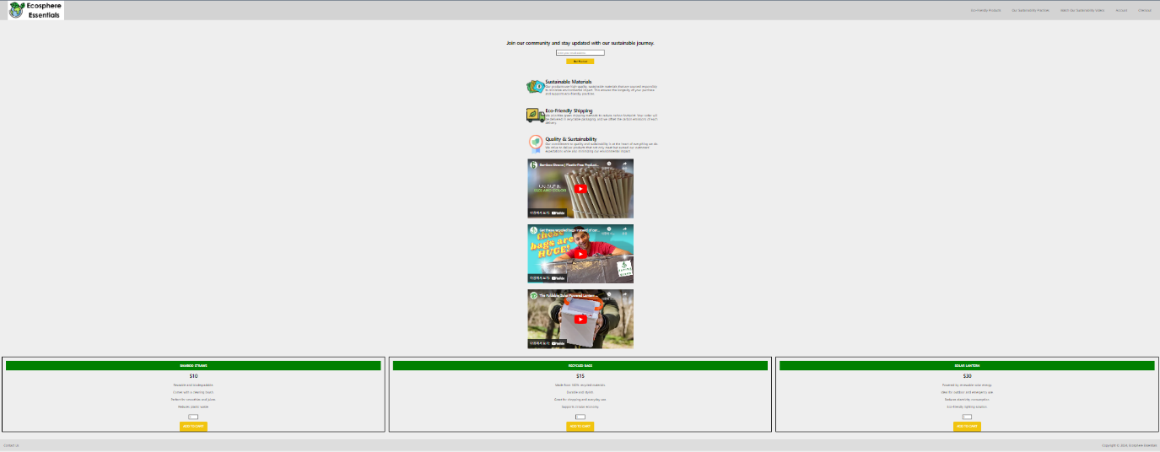

The appearance of our homepage at maximum zoom can be attributed to the responsive design implemented through CSS. The use of flexible layout systems like Flexbox, combined with relative sizing (percentages for width and max width), ensures that elements scale proportionally and maintain their layout integrity when zoomed in. Fixed positioning for the header keeps it in place across different zoom levels, ensuring usability. JavaScript enhances user interaction without affecting zoom appearance, by managing dynamic content like form submissions and notifications effectively.

**Simultaneous Video Playback on the Homepage**

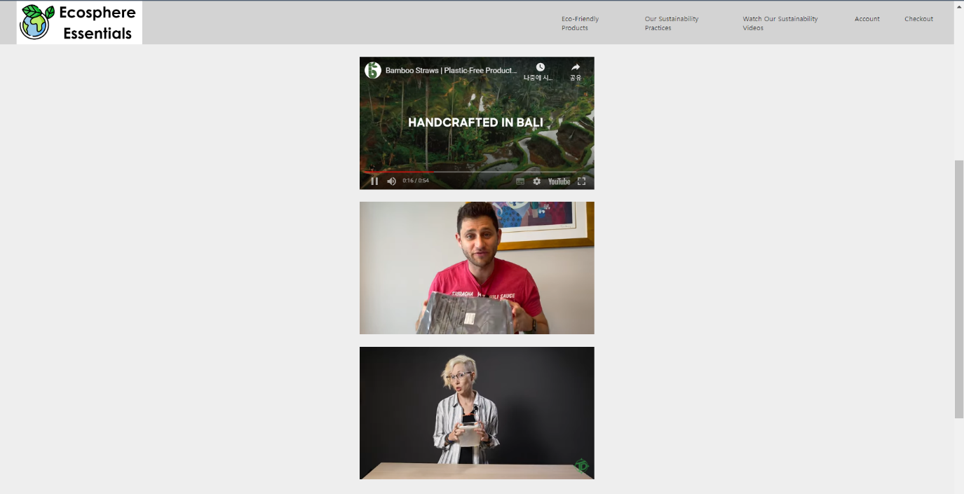

The videos on the homepage are able to play simultaneously when activated because of the standard behavior of embedded video players like YouTube's, which are used here. In the HTML, each video is likely included using an `<iframe>` tag sourced from YouTube. These `<iframe>` elements are independent of each other, meaning that the play state of one video doesn't affect others. There is no JavaScript or CSS in the provided sections of the homepage code that would automatically control or restrict the playback of multiple videos simultaneously. Thus, each video operates independently, allowing users to play all videos at the same time if they choose to do so.

**Email Input Validation on the Homepage's 'Join Our Community' Section**



The email validation message that is seen on the homepage occurs because the JavaScript code associated with your homepage includes a function designed to validate email inputs. Specifically, the function `validateEmail(event)` is triggered when the form is submitted. This function checks whether the email entered matches a regular expression pattern that defines a valid email format. If the email doesn't include an '@' character, the function does not match the required pattern, causing the JavaScript to display an error notification. The regex used (`/^[^\s@]+@[^\s@]+\.[^\s@]+$/`) specifically looks for the presence of '@' followed by a domain and a top-level domain, ensuring the email address is in a standard format. This validation helps prevent incorrect or incomplete email addresses from being submitted, ensuring that only valid emails are accepted for our community updates.

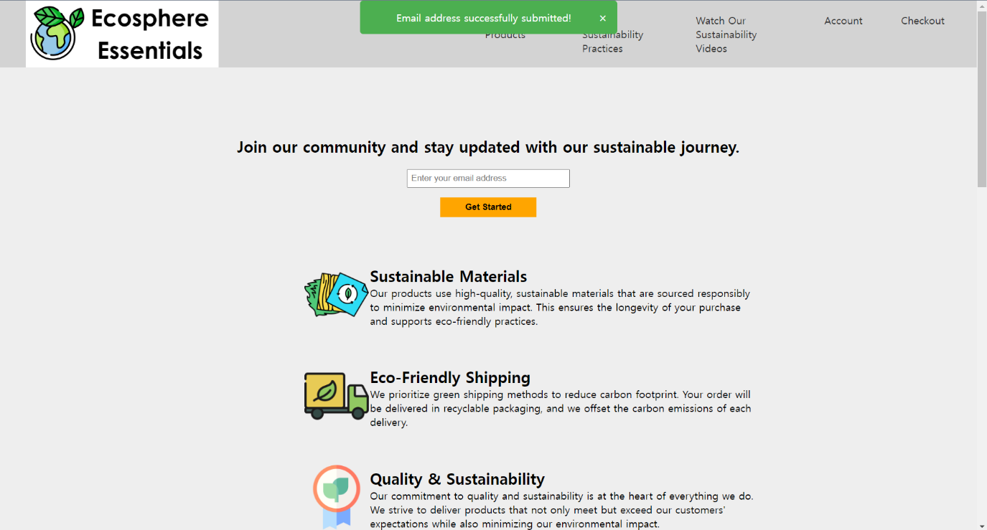

When a valid email is entered in the "Join our community" section of your homepage, the JavaScript function attached to the form's submission event validates the email format. If valid, it calls another function to display a success notification at the top of the page. This notification is controlled by JavaScript, which changes the display style of a predefined HTML element, making the success message visible immediately upon successful validation. CSS is used to style and position the notification appropriately on the page.

**Handling Non-Numeric and Decimal Inputs in Quantity Fields**

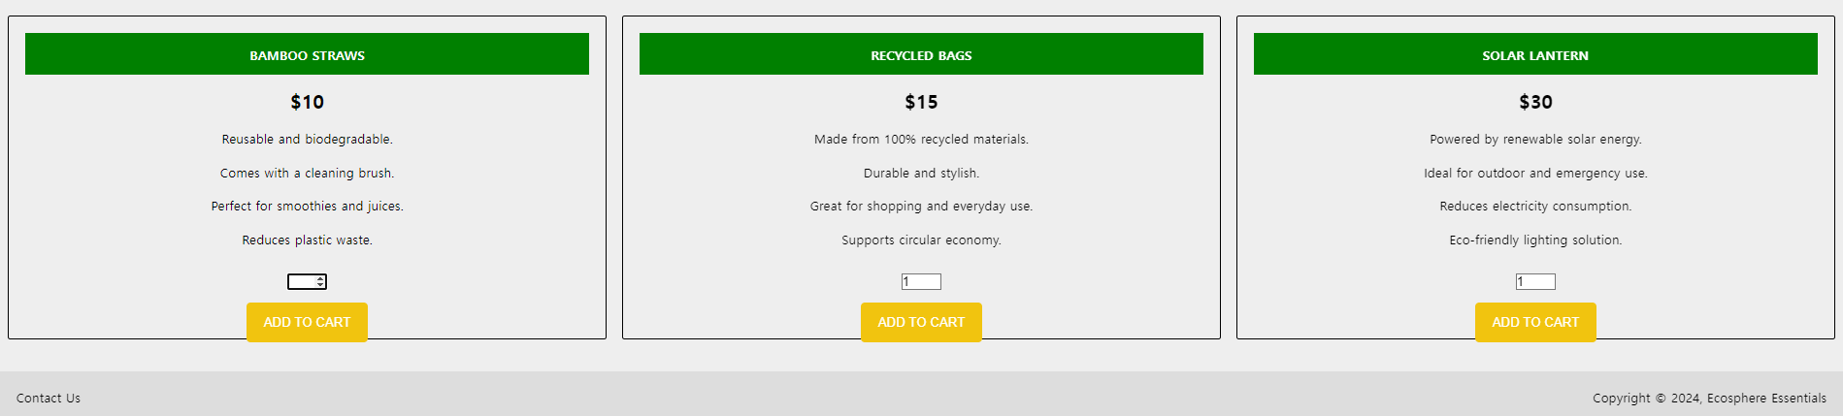

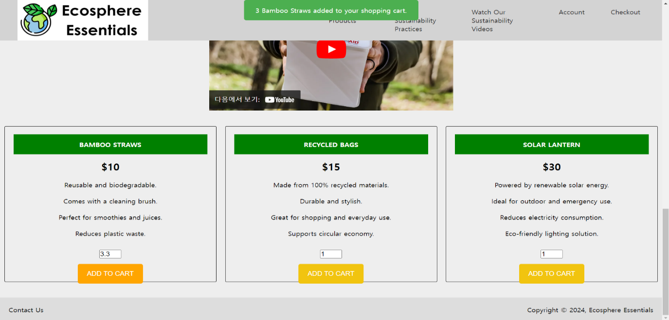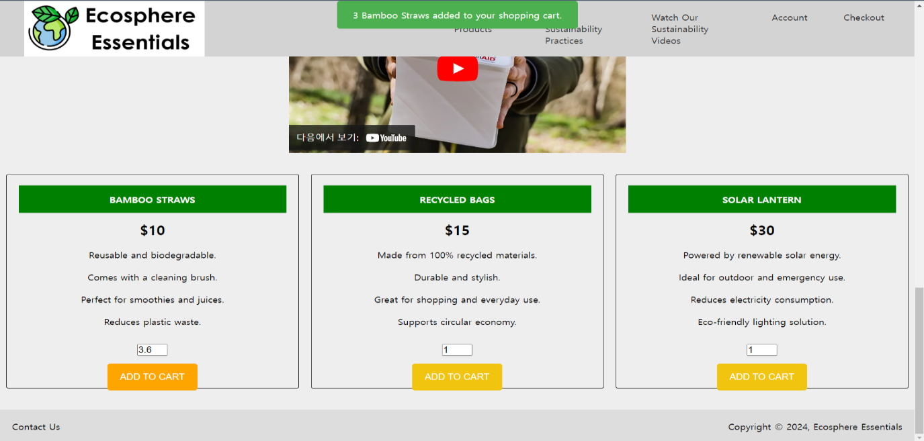

The behavior of the quantity input fields on the homepage, where non-numeric entries reset to blank and decimal numbers round to integers, is controlled by the HTML and JavaScript. The `type="number"` attribute in the HTML input fields ensures only numeric values are accepted, automatically discarding non-numeric characters. Furthermore, these fields likely use the `step="1"` attribute or a JavaScript validation script, which rounds decimal entries to the nearest integer, ensuring users can only enter whole numbers, aligning with typical e-commerce practices for specifying product quantities.

**Prompt for Correct Email Entry During Registration and Login on the Account Page**

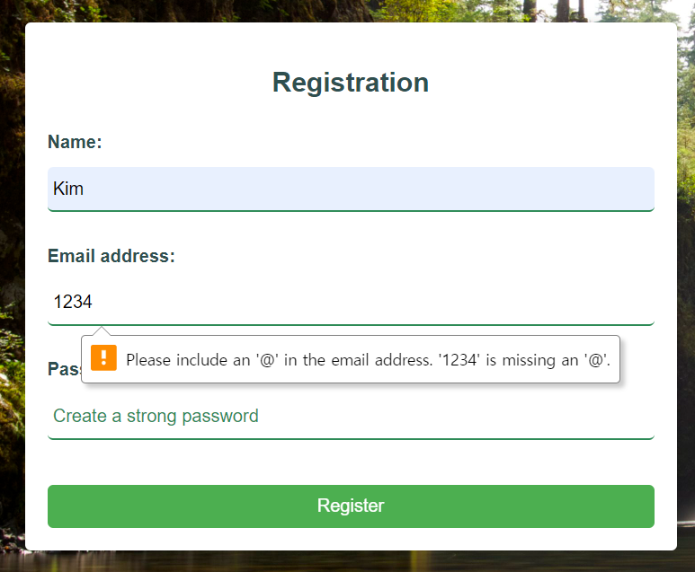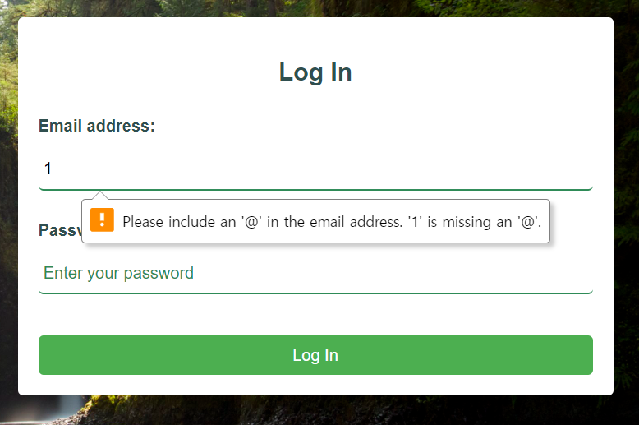

The warning message displayed when an incorrect email format is entered in the registration or login forms on the account page is due to JavaScript validation implemented in our webpage's functionality. In the JavaScript code, there are likely functions that get triggered when either form is submitted. These functions check if the email inputs match a specific pattern that includes an '@' character, using a regular expression. If the input doesn't meet this criterion, the script dynamically displays a notification or error message advising the user to include an '@' in the email address for both the registration and login forms. This ensures that users provide a valid email format before either form can be successfully submitted, enhancing the form's data integrity and maintaining consistent validation across both forms.

**Email Validation and Notification Handling on the Contact Us Page**

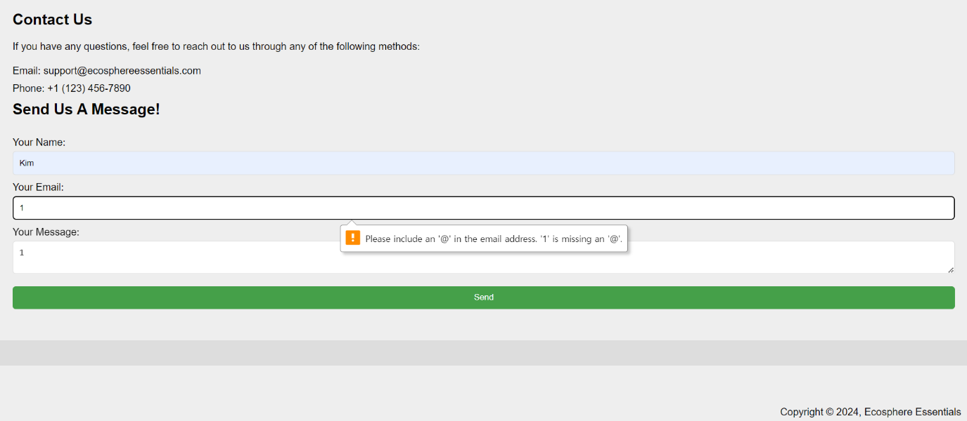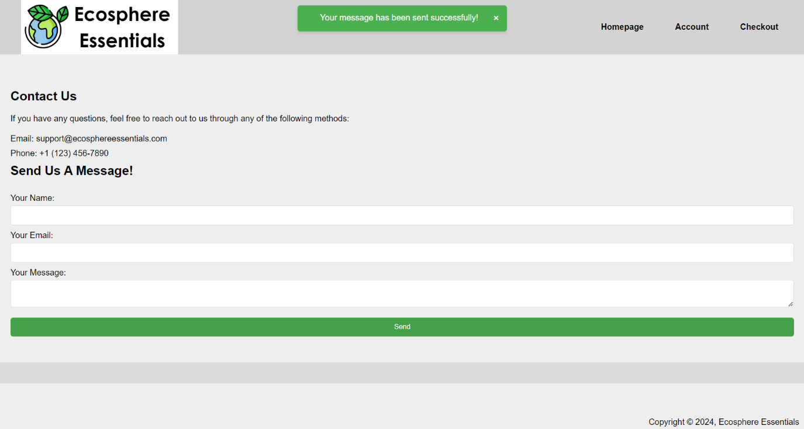

The warning messages and confirmation notifications on the "Contact Us" page are controlled by JavaScript, which validates the email format upon form submission. If the email lacks an '@', JavaScript triggers a warning message; if the email is valid, it displays a success notification. This process is managed by JavaScript functions checking the input against a regular expression and then updating the page's DOM to show the appropriate message, with CSS styling these elements for visibility and consistency with the site's design.

**Comprehensive Validation and Processing Procedures on Our Checkout Page**



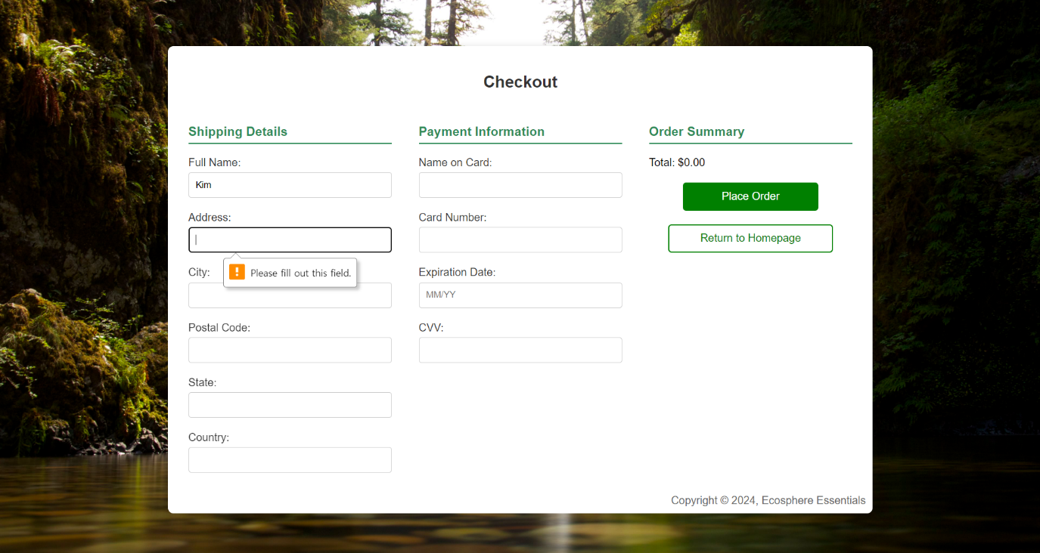

The warnings on the Checkout page are generated by JavaScript and HTML5 validations: When "Place Order" is clicked with an empty cart, JavaScript checks if the cart is empty and displays a green notification prompting the user to add items. Similarly, the "Please fill out this field" message appears due to HTML5's `required` attributes on form inputs. If a user attempts to submit the form with missing information in these required fields, the browser automatically prompts them to complete the fields before proceeding. This ensures a seamless and error-free checkout process.

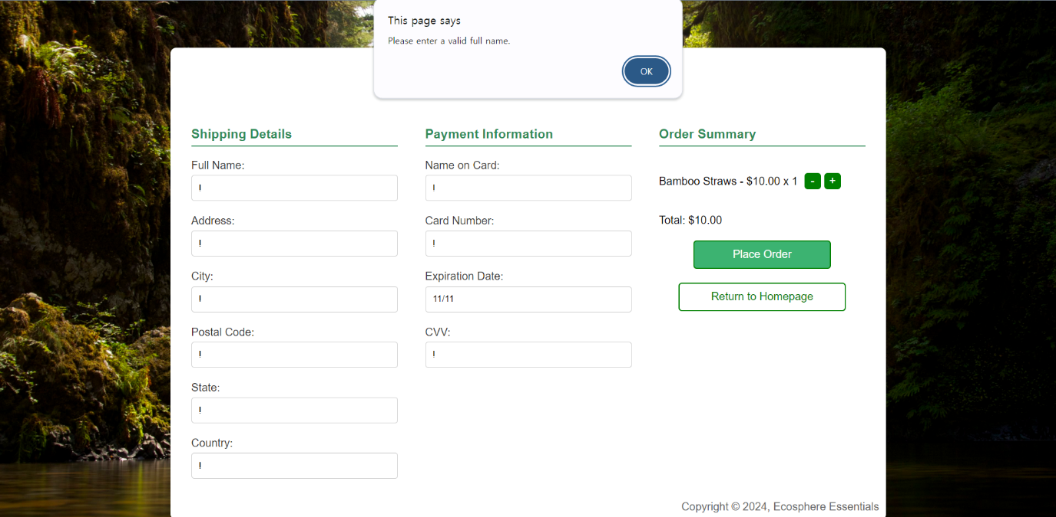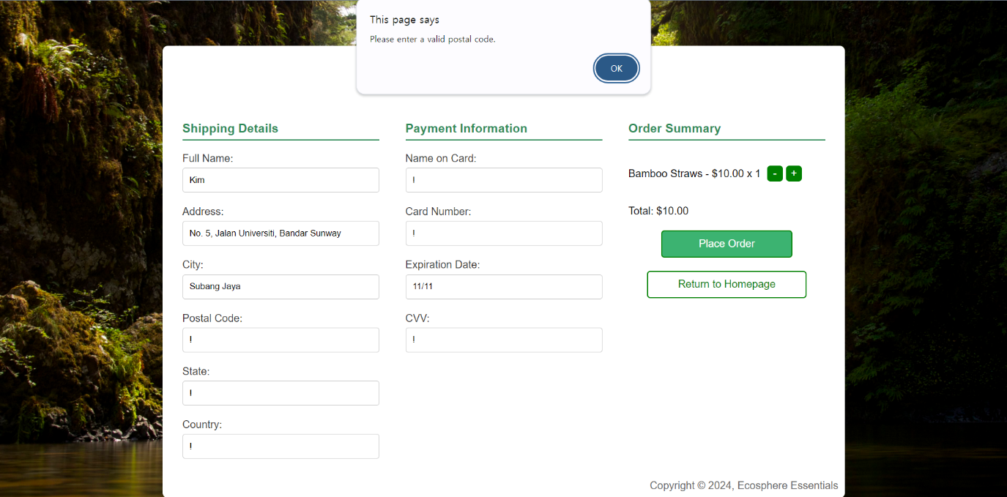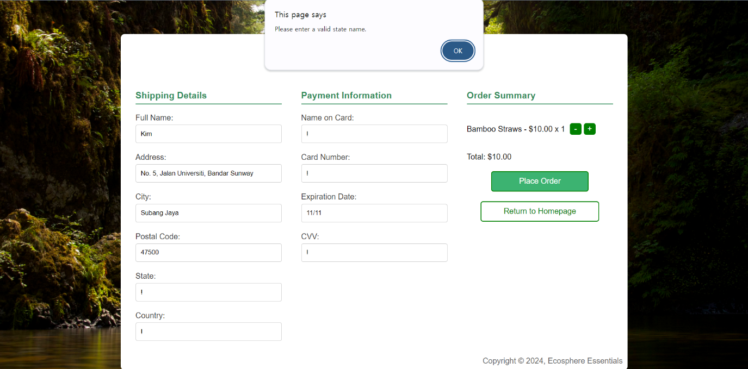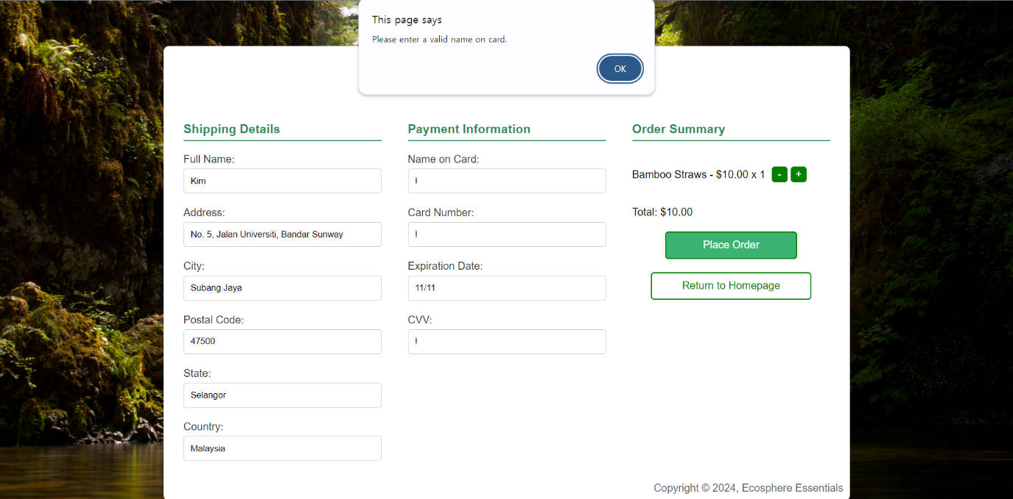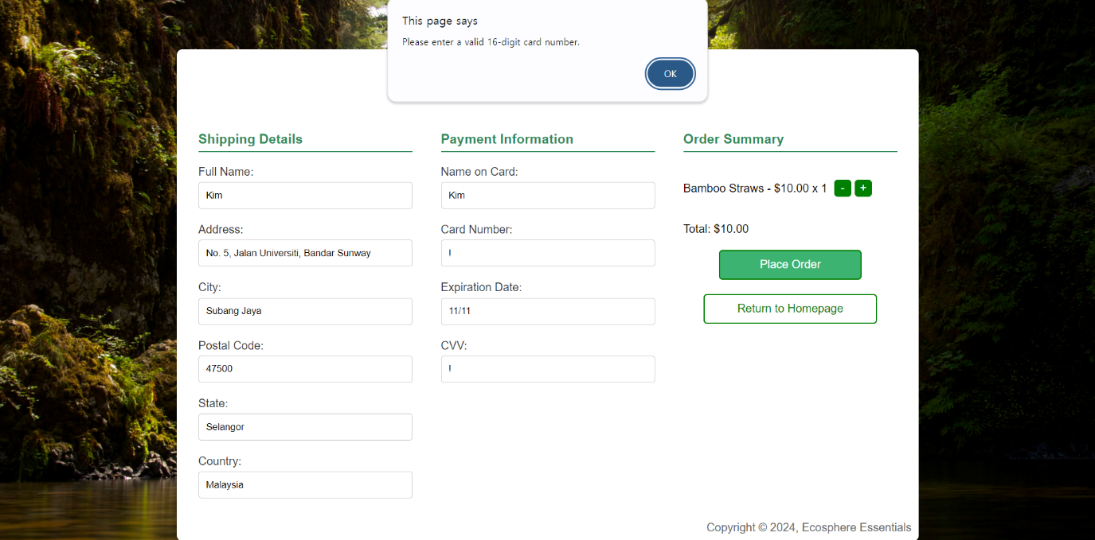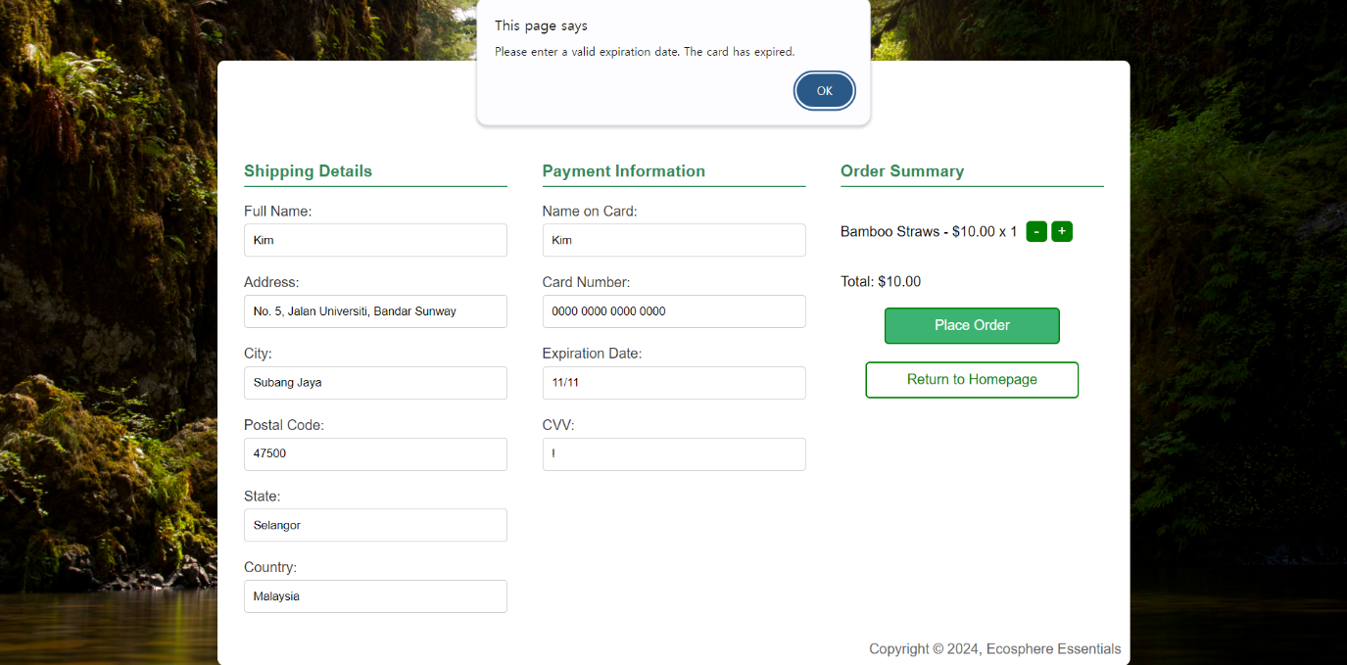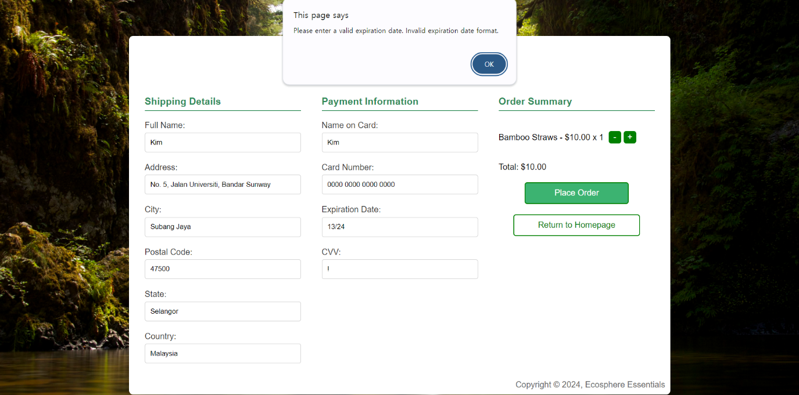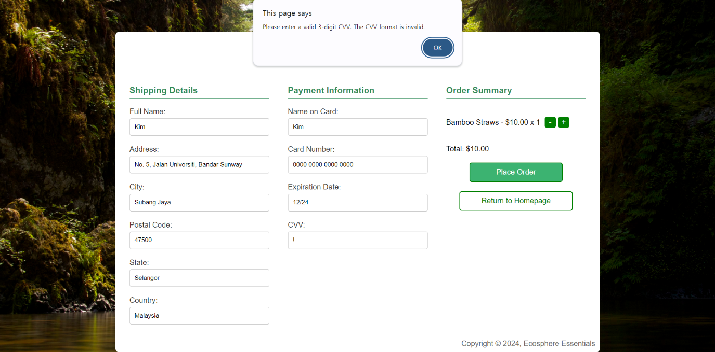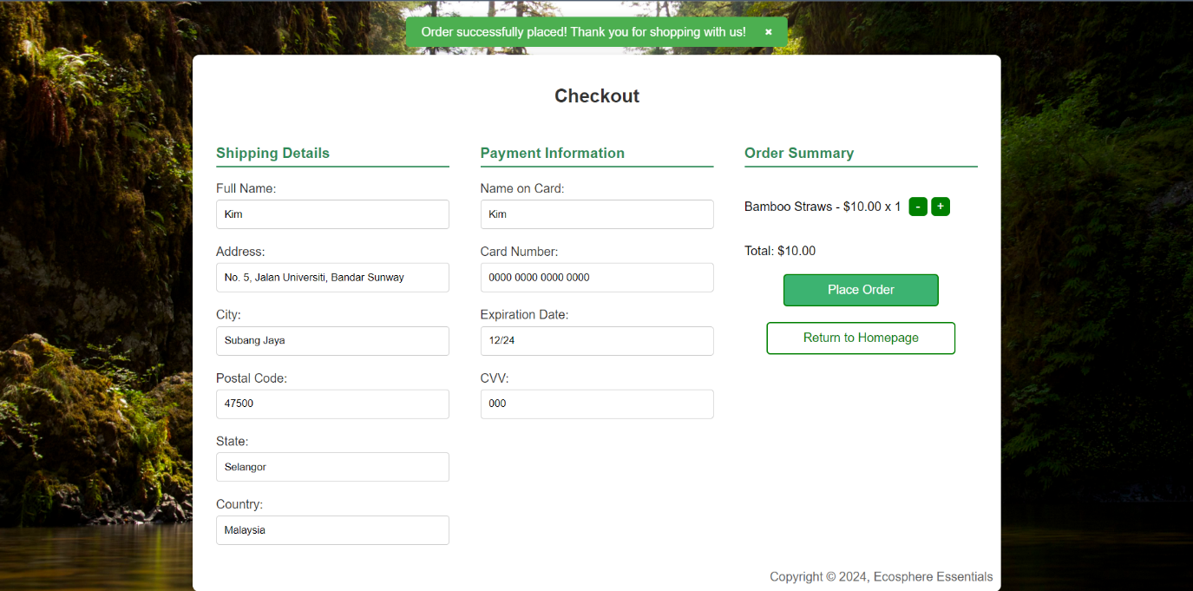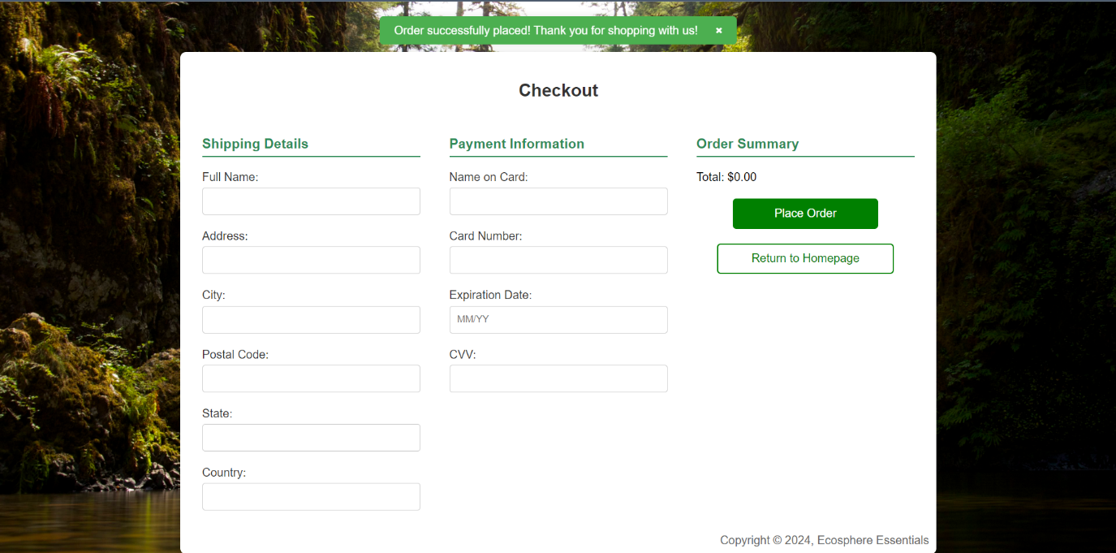

The Checkout page on our website employs HTML5 and JavaScript to validate and ensure that all inputs, such as full name, postal code, state name, name on card, card number, expiration date, and CVV, are correctly entered. HTML5 attributes like `type`, `maxlength`, and `pattern` are used to enforce format and length directly in the browser for immediate feedback. JavaScript is instrumental in handling complex validations and error messaging. This includes checking the validity of the expiration date on credit cards, where it parses the month and year from the input and verifies if the month is between "01" and "12" and if the card has not expired compared to the current date. If the month entered is something invalid like "13" or the card's expiration date is past, JavaScript dynamically displays appropriate error messages to prompt users for corrections. Once all fields meet the validation criteria, JavaScript enables the form submission, allowing the order to be processed securely. This thorough validation process ensures data integrity and security before any transaction is completed, maintaining a high standard of user experience and data accuracy on our Checkout page.

**References**

Bambaw (2020, October 23). *Bamboo straws | Plastic-free products | Zero-waste essentials | Bambaw* [Video]. YouTube. https://youtu.be/9EnY_Nyu8m8?si=K3lDNT1awTSOttx2

Saving Green (2022, December 21). *Get these recycled bags instead of cardboard moving boxes!* [Video]. YouTube. https://youtu.be/Nux_AvcZXtc?si=8tvzAZBRAbLlo-Zn

Terradrift (2021, March 26). *The foldable, solar powered lantern that charges your phone!* *LuminAID PackLite Titan review* [Video]. YouTube. https://youtu.be/IuXw7xxZmww?si=0Fjltsd5EoBjQaNc

Tropical forest, *forest, fall, shade, daple, water, beauty, rainforest, nature, HD wallpaper | Peakpx.* (n.d.). Www.peakpx.com. Retrieved July 4, 2024, from https://www.peakpx.com/en/hd-wallpaper-desktop-fkjip.

**Appendix**

**Meeting Records**

|  |  |  |
| --- | --- | --- |
| **Date** | **Attended by** | **Items Discussed** |
| **01.07.2024** | **ALL** | A Microsoft Teams group chat was created on 1 July 2024 at 11 PM, and all members of the group are added. This group report was shared with other members to insert their name, student identification number and signature. |
| **03.07.2024** | **ALL** | Held an audio call on 3 July 2024 at 9 PM to discuss and finalise project ideas, assigned group responsibilities, and created a GitHub repository for easy code sharing and storing. |
| **11.07.2024** | **ALL** | Held a chat meeting on 11 July 2024 at 10:30 PM to share current progress and discuss completed tasks among team members. |
| **14.07.2024** | **ALL** | Held a chat meeting on Microsoft Teams at 11:40 AM to review each other's parts and provide feedback. |
| **28.07.2024** | **ALL** | Held a chat meeting at 11:30 PM to exchange opinions about the video. |
| **29.07.2024** | **ALL** | Held a chat meeting at 7:30 AM to share updates on website modifications and report current progress. |
| **30.07.2024** | **ALL** | Held a chat meeting at 10:30 AM to review the website and share updates on current progress. Discussed code issues, tested the code, provided feedback, and discussed additional elements to be added to the website. |
| **31.07.2024** | **ALL** | Held a chat meeting at 5:50 PM to talk about the individual reflection and the peer evaluation. |
| **01.08.2024** | **ALL** | Held a chat meeting at 10 AM to finalize the document and do a successful submission. |

**Activity Logs**

|  |  |  |
| --- | --- | --- |
| **Date** | **Progress** | **Recorded by** |
| **01.07.2024** | Made Shared group report. | Kim Hyunwoo |
| **07.03.2024** | Made GitHub repository. | Kim Hyunwoo |
| **11.07.2024** | Completed the HTML script for the Checkout page. | Kim Hyunwoo |
| **14.07.2024** | Accomplished the CSS and JavaScript development for the Checkout page. Also Completed part of the HTML scripts related to the homepage. | Kim Hyunwoo |
| **29.07.2024** | Wrapped up the CSS and JavaScript for the homepage. | Kim Hyunwoo |
| **30.07.2024** | Concluded the HTML, CSS, and JavaScript for the account page. Additionally, reviewed the entire code and resolved issues. | Kim Hyunwoo |
| **31.07.2024** | Finished making the video and writing the individual reflection. | Kim Hyunwoo |
| **01.08.2024** | Finalized and documented the project report and conducted the peer evaluation. | Kim Hyunwoo |